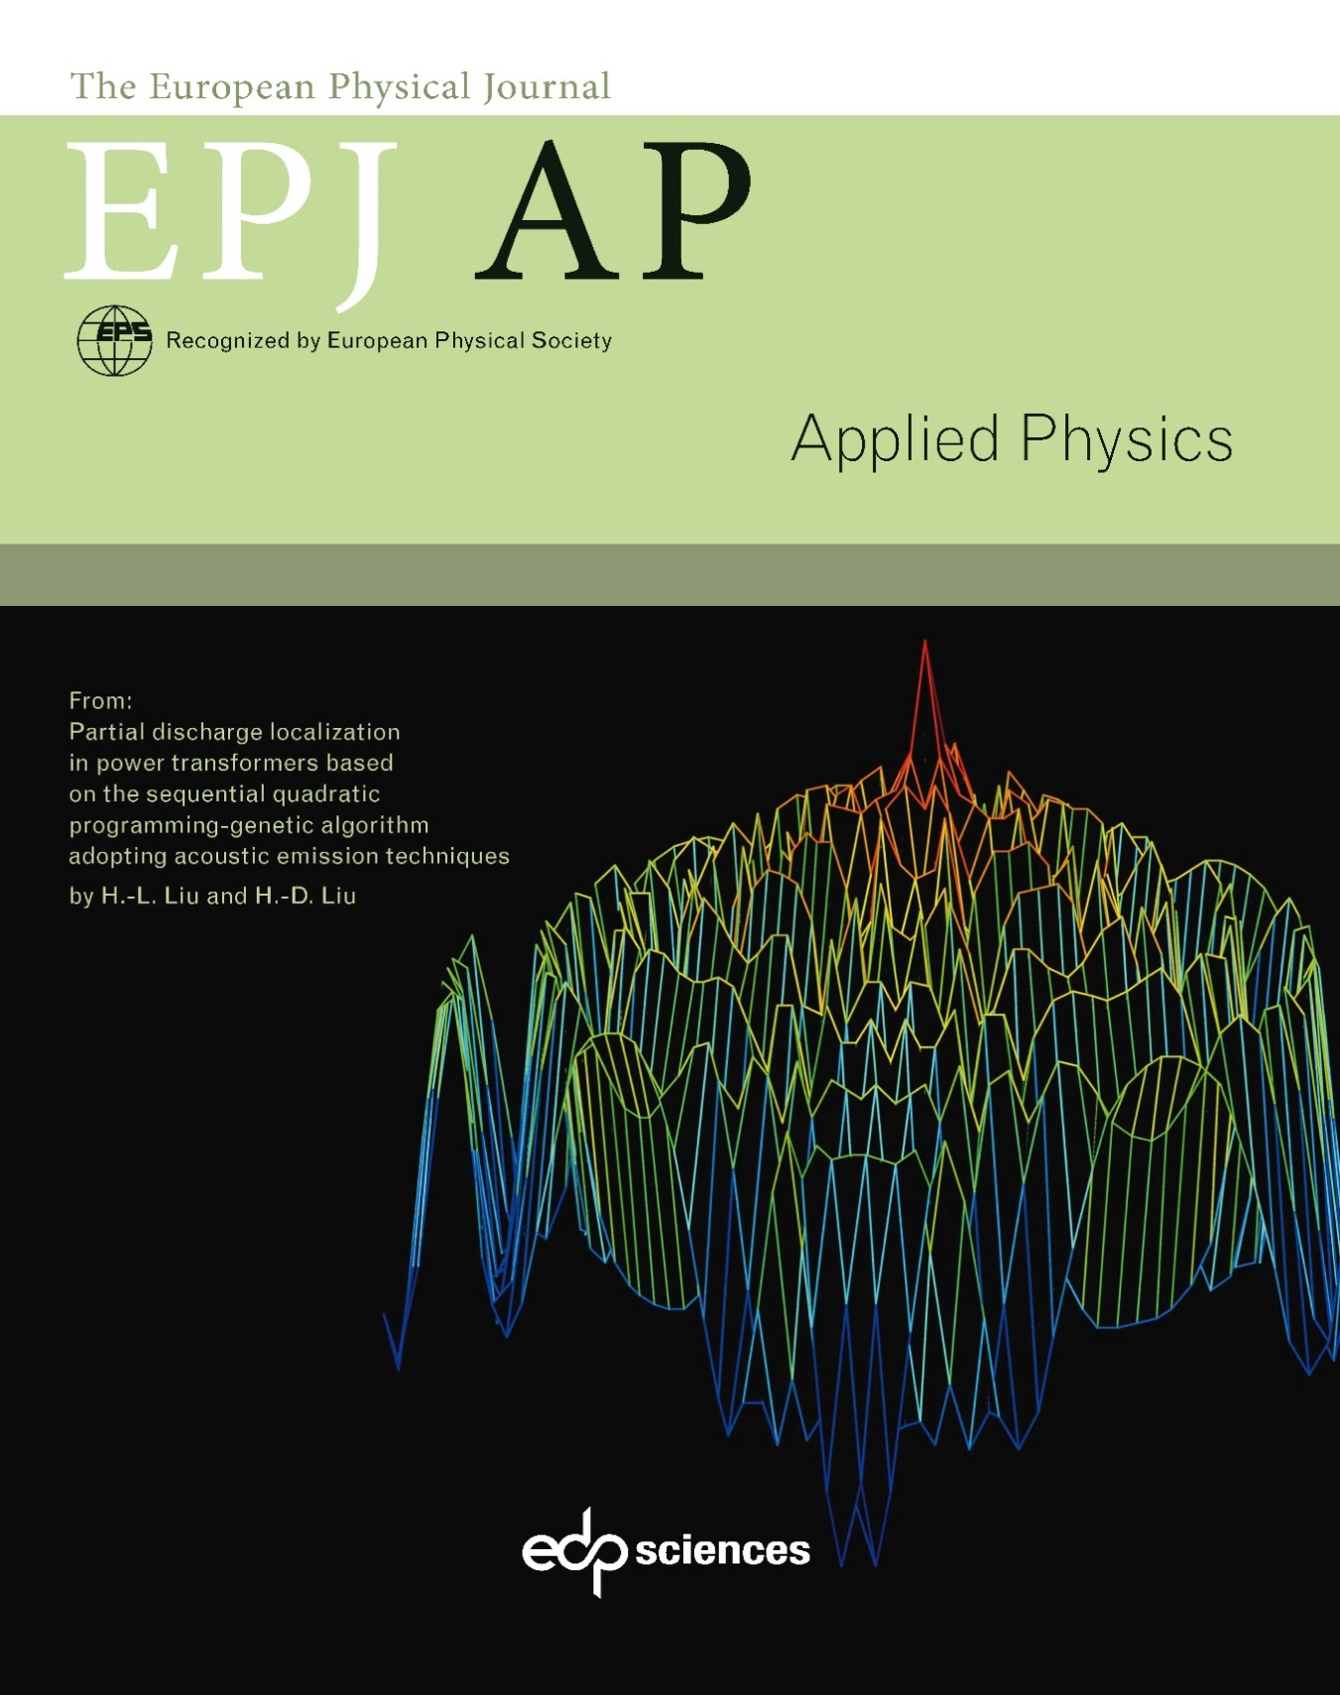

**Call for papers**

Special Issue on Electromagnetic modeling:

from material properties to energy systems

Guest Editors

* ***Dr. Lionel Pichon****, CNRS, France*
* ***Prof. Junwu Tao****, Université de Toulouse, France*

**NUMELEC 2024**

The special issue welcome contributions presented at NUMELEC 2024. The10th European Conference on Numerical Methods in Electromagnetism (NUMELEC 2024) will take place from July 8 to 10 in Toulouse at Toulouse INP-ENSEEIHT. The aim of NUMELEC is to offer the two

communities working in the fields of low and high frequencies the opportunity to meet and exchange views on the latest advances in their research. The three-day conference will feature joint oral and poster sessions, discussions on common topics, and the development of useful guidelines for both communities. The areas covered will include methodological aspects such as formulations of electromagnetic problems in static, quasi-static or variable regimes, resolution and optimization methods, as well as applicative aspects linked to the modeling of materials and devices.

**Aim and Scope of the Themed Issue**

The aim of this Special Issue on electromagnetic modeling is to assemble high-quality papers that include the recent progress and current research about numerical methods, modelling tools and optimization algorithms in electrical and electronic engineering. It will cover both low frequency applications involving energy systems and coupled problems and high frequency applications related to wave propagation and electromagnetic compatibility.

The design and optimization of complex systems in electrical and electronic engineering require appropriate modelling tools to face multiscale problems and/or multiphysics aspects. To face large scale problems or high miniaturization of devices, traditional and historical approaches have sometimes to be combined or hybridized. They also need to be thought and developed in a context of high-performance computing, model reduction and learning techniques to contribute to new challenges in artificial intelligence and digital twins within the engineering community.

Scope of papers that will be considered for publication in this Special Issue covers: (i) the current trend and latest research on mathematical modelling and formulations, discretization methods and numerical techniques, optimization algorithms and (ii) their applications in energy and electrical engineering. Specific areas of interest include multi-physics and coupled problems; electric vehicle and wireless power transfer; antennas and electromagnetic compatibility; electrical machines and power electronics; non-destructive testing and diagnosis, and other relevant topics.

**Submissions**

All relevant papers will be carefully considered, reviewed by a distinguished team of international experts, and published in accordance to the [Journal’s standard policies](https://www.epjap.org/about-the-journal/ethical-standards). Full research papers and comprehensive review articles can be submitted online via the journal’s [submission and peer review site](https://articlestatus.edpsciences.org/is/epjap/home.php).

**Submission deadline – July 31st 2024**

**Charges**

1. There is no submission charge in EPJAP.
2. For papers that have not chosen the Open Access Option (those papers will be read only by subscribers), there are **no publication charges.**
3. Open Access Option

To favour a broad and easy access to all published scientific information, EPJ AP uses a service called [Open Access Option (OAO)](https://www.epjap.org/author-information/open-access-option-oao). It offers the possibility for authors to make their papers freely available to all interested readers (subscribers or non subscribers) as soon as the articles are published online, in exchange for payment of a [basic fee](https://www.edpsciences.org/en/publication-charges#epjap).

* *Waivers and Discounts concerning the Open Access Option:*
* *EDP Sciences provides a waiver to authors based in countries included in*[*Group A of the Research4Life programme*](https://www.research4life.org/access/eligibility/#groupa)
* *EDP Sciences has signed an APC agreement with the NSLC (National Science Library CAS) the research library service system for the Chinese Academy of Sciences (CAS). Corresponding authors affiliated with*[*one of the eligible CAS institutes*](https://www.edpsciences.org/images/stories/waivers/CAS-institutes.pdf)*, can publish in open access at a 20 percent discounted APC price.*
* *EDP Sciences has signed with the Technische Informationsbibliothek (TIB) a German National APC agreement. Corresponding authors affiliated with German academic institutions including universities and research institutions, can publish in open access at a 20 percent discounted APC price.*
* *Corresponding authors from* [*French institutions*](https://www.edpsciences.org/en/national-open-access-agreement-in-france/list-of-member-institutions-in-2021) *having signed* [*the National Open Access agreement in France*](https://www.edpsciences.org/en/national-open-access-agreement-in-france)*, can publish in Open Access without any fee.*

**Abstracting/indexing**

The European Physical Journal Applied Physics (EPJ AP) is indexed/abstracted in:

* [ADS (Nasa)](http://adswww.harvard.edu/)
* Baidu Scholar
* [Cambridge Scientific abstracts (CSA)](https://www.proquest.com/)
* [Chemical Abstracts Service (CAS)](http://www.cas.org/)
* [CNKI](http://oversea.cnki.net/kns55/default.aspx)
* Current Contents/Physical, Chemical & Earth Sciences
* [EBSCOhost](https://www.ebsco.com/products/research-databases/)
* [EI Compendex](https://www.engineeringvillage.com/home.url)
* [Google Scholar](https://scholar.google.com/)
* IHS
* [IET INSPEC](https://www.theiet.org/publishing/inspec/)
* PASCAL
* Portico
* Science Citation Index Expanded (Web of Science)
* [Scopus](http://www.scopus.com/)
* TIB Llizenzen Technische Informationsbibliothek (TIB)
* [Wanfang Data](http://www.wanfangdata.com/index.asp)

**2022 Impact Factor*: 1.0**

*JCR, Clarivate Analytics © 2023

**Editorial board**

**Editors-in-Chief**

**Suzanne GIORGIO**, Aix Marseille University - Polytech/Department of Material Sciences, Research at the Interdisciplinary Center of Nanosciences of Marseille (CINaM), FRANCE

**Damien JACOB**, University of Lille, Lab. UMET, Earth and Planetary Materials group, Lille, FRANCE

**Associate Editors**

**Guilhem ALMUNEAU**, LAAS CNRS, Toulouse, FRANCE

**Pascal ANDREAZZA,** Université d'Orléans- ICMN, Nanostructured and Confined System, Group, Orléans, FRANCE

**Raul ARENAL,** Instituto de Nanociencia y Materiales de Aragon (INMA), Universidad de Zaragoza, SPAIN

**Manfred BAYER**, Technische Universität, Dortmund, Lehrstuhl für Experimentelle Physik I, Dortmund, GERMANY

**Ramesh Chandra BUDHANI**, Department of Physics, Morgan State University, US

**Subhasish DUTTA GUPTA**, School of Physics, University of Hyderabad, INDIA

**Christopher EWELS**, Institut des Matériaux Jean Rouxel, Nantes, FRANCE

**Bruno GALLAS**, Institut des NanoSciences de Paris (INSP), FRANCE

**Irina GRAUR MARTIN**, Polytech Marseille, Aix-Marseille Université, FRANCE

**Mathieu KOCIAK**, Université Paris-Sud, Laboratoire de Physique des Solides, Orsay, FRANCE

**Christine LEROUX**, Université de Toulon, IM2NP, FRANCE

**Yuxiang LI**, Shandong University, School of Physics, CHINA

**Robert MARTIN**, University of Strathclyde, Department of Physics, Glasgow, UK

**Michel NÉGRERIE**, École polytechnique, Laboratoire d'Optique et Biosciences, Palaiseau, FRANCE

**Jean-Michel NUNZI**, Queen's University, Department of Chemistry, Kingston, CANADA

**Gilles PATRIARCHE**, C2N, Université Paris Sud, Palaiseau, FRANCE

**Laurent PICCOLO,** IRCElyon, Lyon, FRANCE

**Lionel PICHON,** GeePs – CentraleSupélec, Gif-sur-Yvette, France

**Laurent PIZZAGALLI,** Institute P' SP2MI, Department of Physics and Mechanics of Materials, Futuroscope Chasseneuil, FRANCE

**Joaquim PUIGDOLLERS,** Universitat Politècnica Catalunya, Dept Eng Electrònica and CrNE, Barcelona, SPAIN

**Adel RAZEK,** LGEP – SUPELEC, Gif-sur-Yvette, FRANCE

**Gilles RENAUD,** CEA-Grenoble, IRIG/MEM/NRS, Grenoble, FRANCE

**Ruth V. SABARIEGO,** KU Leuven, Department of Electrical Engineering, Leuven, BELGIUM

**Wilfried SIGLE,** Max Planck-Institut für Metall forschung, StEM, Stuttgart, GERMANY

**Jun XU,** School of Electronic Science and Engineering, Nanjing University, CHINA